General mesh optimization guidelines
Some useful rules to keep in mind
When your meshes are way too polygons heavy and there’s a problem to fit them into memory, especially on consoles. There’s a need to optimize them more or rather fix them so they don't waste polygons as much as they do now.
Delete what is not visible
- This is very true for inaccessible houses
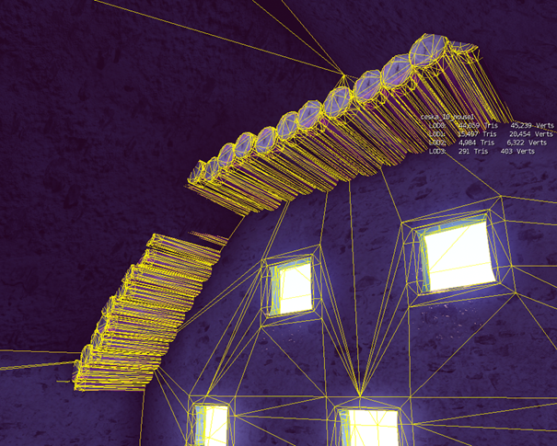
So many polygons are wasted inside inaccessible houses. You can use Slice modifier to easily cut away excessive part
The further from the player, the lower the level of detail
- You can model distant planks according to the LOD1 or LOD2 tri count
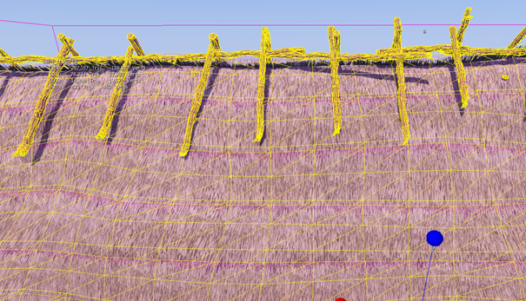
So many polygons, even with LOD2 tri count planks would be perfectly ok here
- Plank used under a dark roof can also be "LODed“
- Do not use planks where not necessary – for example, roof gable in inaccessible houses can use tiling texture instead of actual planks
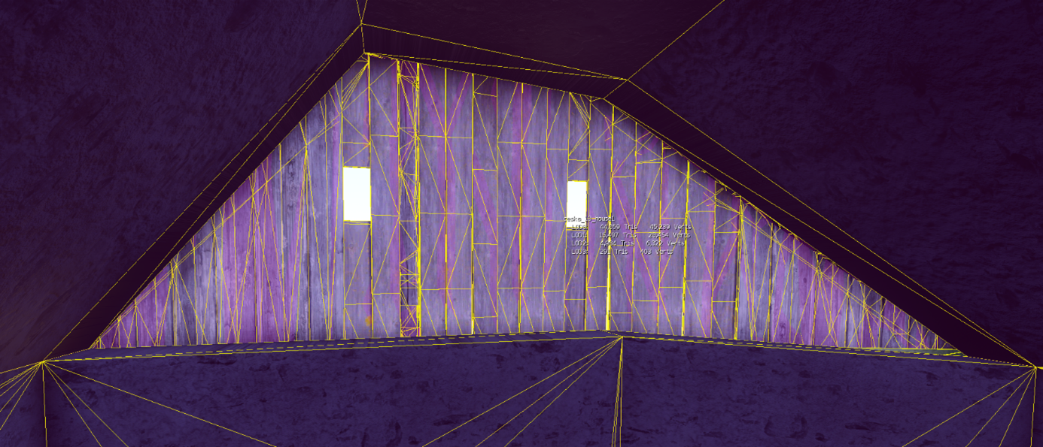
The gable of the inaccessible house is made of planks and has all the polygons inside
- Create the most simple ends where not visible
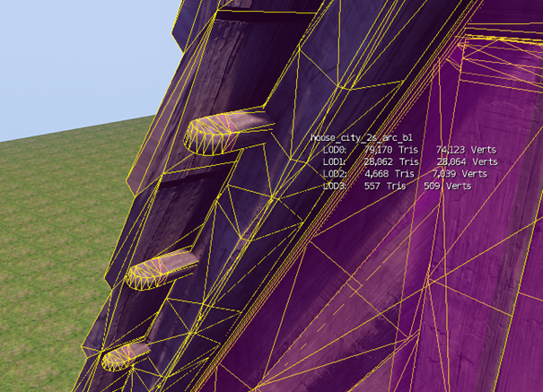
Small beams under the high roof that use polygon-heavy ends, this is not necessary
- Only one layer on the roof edge high above
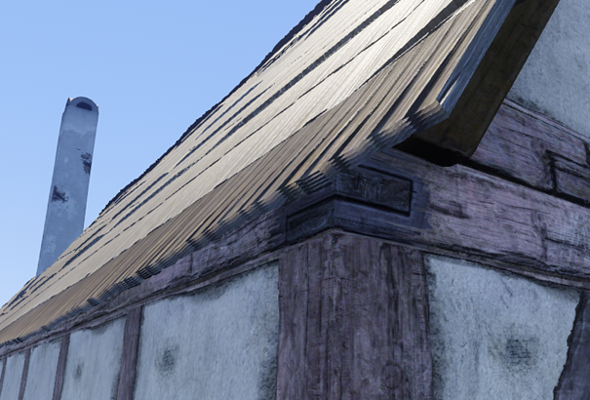
This roof edge is 11 m above the ground, one or two layers are perfectly ok
- Optimize distant arcs
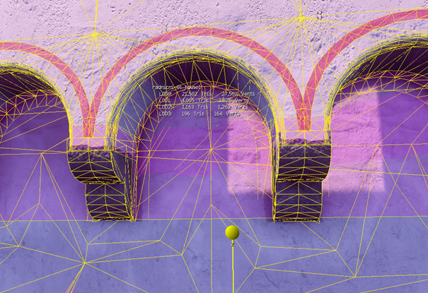
This here is way too much as it’s high above the ground so far from the camera
- Optimize flat walls
- Be careful to avoid tessellated walls for no reason, without vertex paint extra vertices are not used
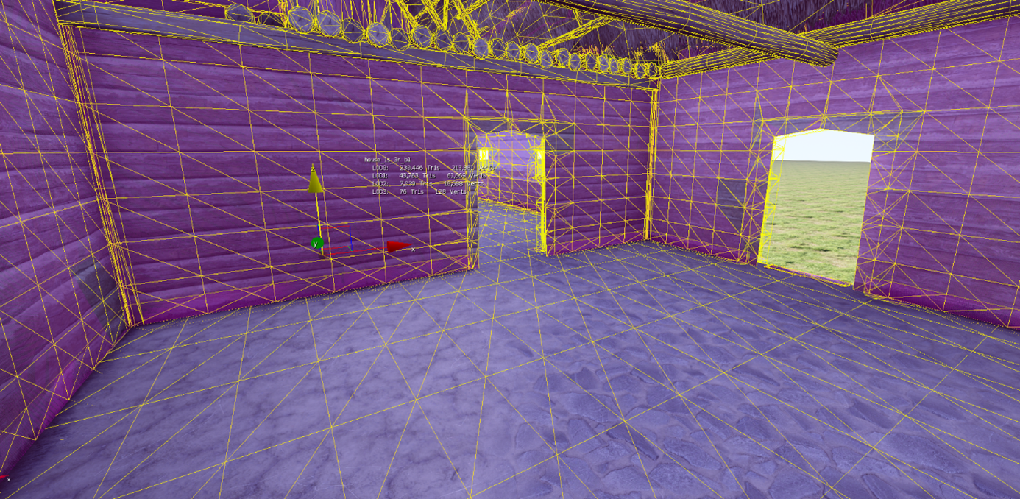
- Same for barely visible high roofs, avoid tessellation too much (this could be valid for houses which are standing next to each other; you need to check in the level first)
- Delete at least every second layer of thatched roofs (and even more for roofs high above the player). Don't delete upmost layer, otherwise the roof edge will be see-through
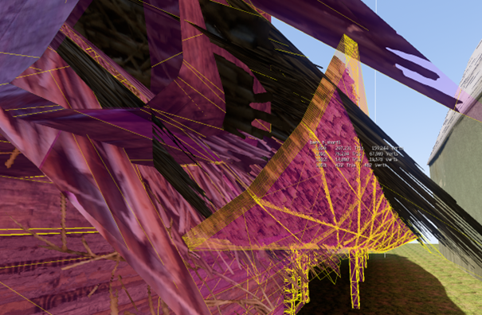
Separate model into multiple cgfs
- Complicated interiors could be separated into their own CGF (for example, basement under the house) and set up with very low ViewDistRatio.
Shadowproxy
- When the optimization is done, if needed, remember to rebuild Shadowproxy and LODs

